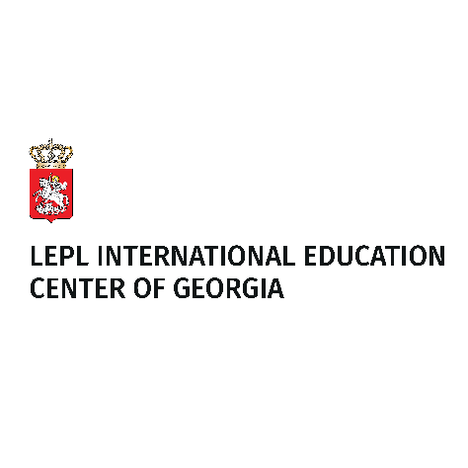

# STUDY/RESEARCH/SUMMER SCHOOL VISITS IN GEORGIA 2025-2026

# APPLICATION FORM

|  |  |  |
| --- | --- | --- |
| **Academic year** |  |  |
| **Length of study/research stay/Summer School** |  |
| **Period** |  |

|  |  |  |  |  |  |  |  |
| --- | --- | --- | --- | --- | --- | --- | --- |
| **APPLICANT DATA** | |  | |  | |  | |
| **Family name** | |  | | **First name(s)** | |  | |
| **Gender** | |  | | **Date and place of birth** | |  | |
| **Citizenship** | |  | | **International passport N** | |  | |
| **E-mail** | |  | | **Telephone/Fax**  **(in international format)** | |  | |
| **Permanent residence address** | |  | | | | | |
| **Mailing address (if different from above)** | |  | | | | | |
| **Person to be notified in case of emergency (name, address, phone,**  **e-mail)** | |  | | | | | |
| **EDUCATIONAL BACKGROUND** | | |  | |  | |  |
|  | **School/university** | | **from (year) to (year)** | | **Field of study** | | **Degree/diploma/**  **other certificate** |
| **Secondary Education** |  | |  | |  | |  |
| **Higher education – Bachelor’s degree programme** |  | |  | |  | |  |
| **Higher education – Master’s degree programme** |  | |  | |  | |  |
| **Higher education – postgraduate study or research (Ph.D. level)** |  | |  | |  | |  |
| **Other** |  | |  | |  | |  |

|  |  |  |  |  |
| --- | --- | --- | --- | --- |
| **LANGUAGE PROFICIENCY** | | | | |
| **Languages** | **Skills – please indicate the appropriate level using a scale ranging from A1 (beginner) to C2 (near native speaker level)** | | | |
| **Listening** | **Reading** | **Speaking** | **Writing** |
|  |  |  |  |  |
|  |  |  |  |  |
|  |  |  |  |  |

|  |  |
| --- | --- |
| **PLANNED STUDIES/VISIT IN GEORGIA** | |
| **Preferred host institution of higher education** |  |
|  |
| **Field of study/research or name of summer school you wish to pursue/attend** |  |
| **The main objective of your planned study/research stay in Georgia (Max 350 word)** |  |

|  |  |  |
| --- | --- | --- |
| **I ATTACH THE FOLLOWING DOCUMENTS:** | | |
|  | * **Academic CV** * **Two letters of recommendation from academic supervisors** * **Proof of active student status or employment;** | * **Passport/ ID copy** * **Letter of acceptance/invitation** |
|
|
| **All documents must be written in or translated into English.** | | |

* **I have been duly apprised of the terms pertaining to the scholarship.**
* **I hereby affirm and certify that all information provided in this application is accurate and true to the best of my knowledge.**
* **By completing this application, I hereby acknowledge that my personal data, as provided in this application form and accompanying attachments, will be shared with the Ministry of Education, Science, and Youth of Georgia, as well as affiliated universities, for the purpose of consideration and nomination for the Scholarship program.**

**Signature:**

**Date:**