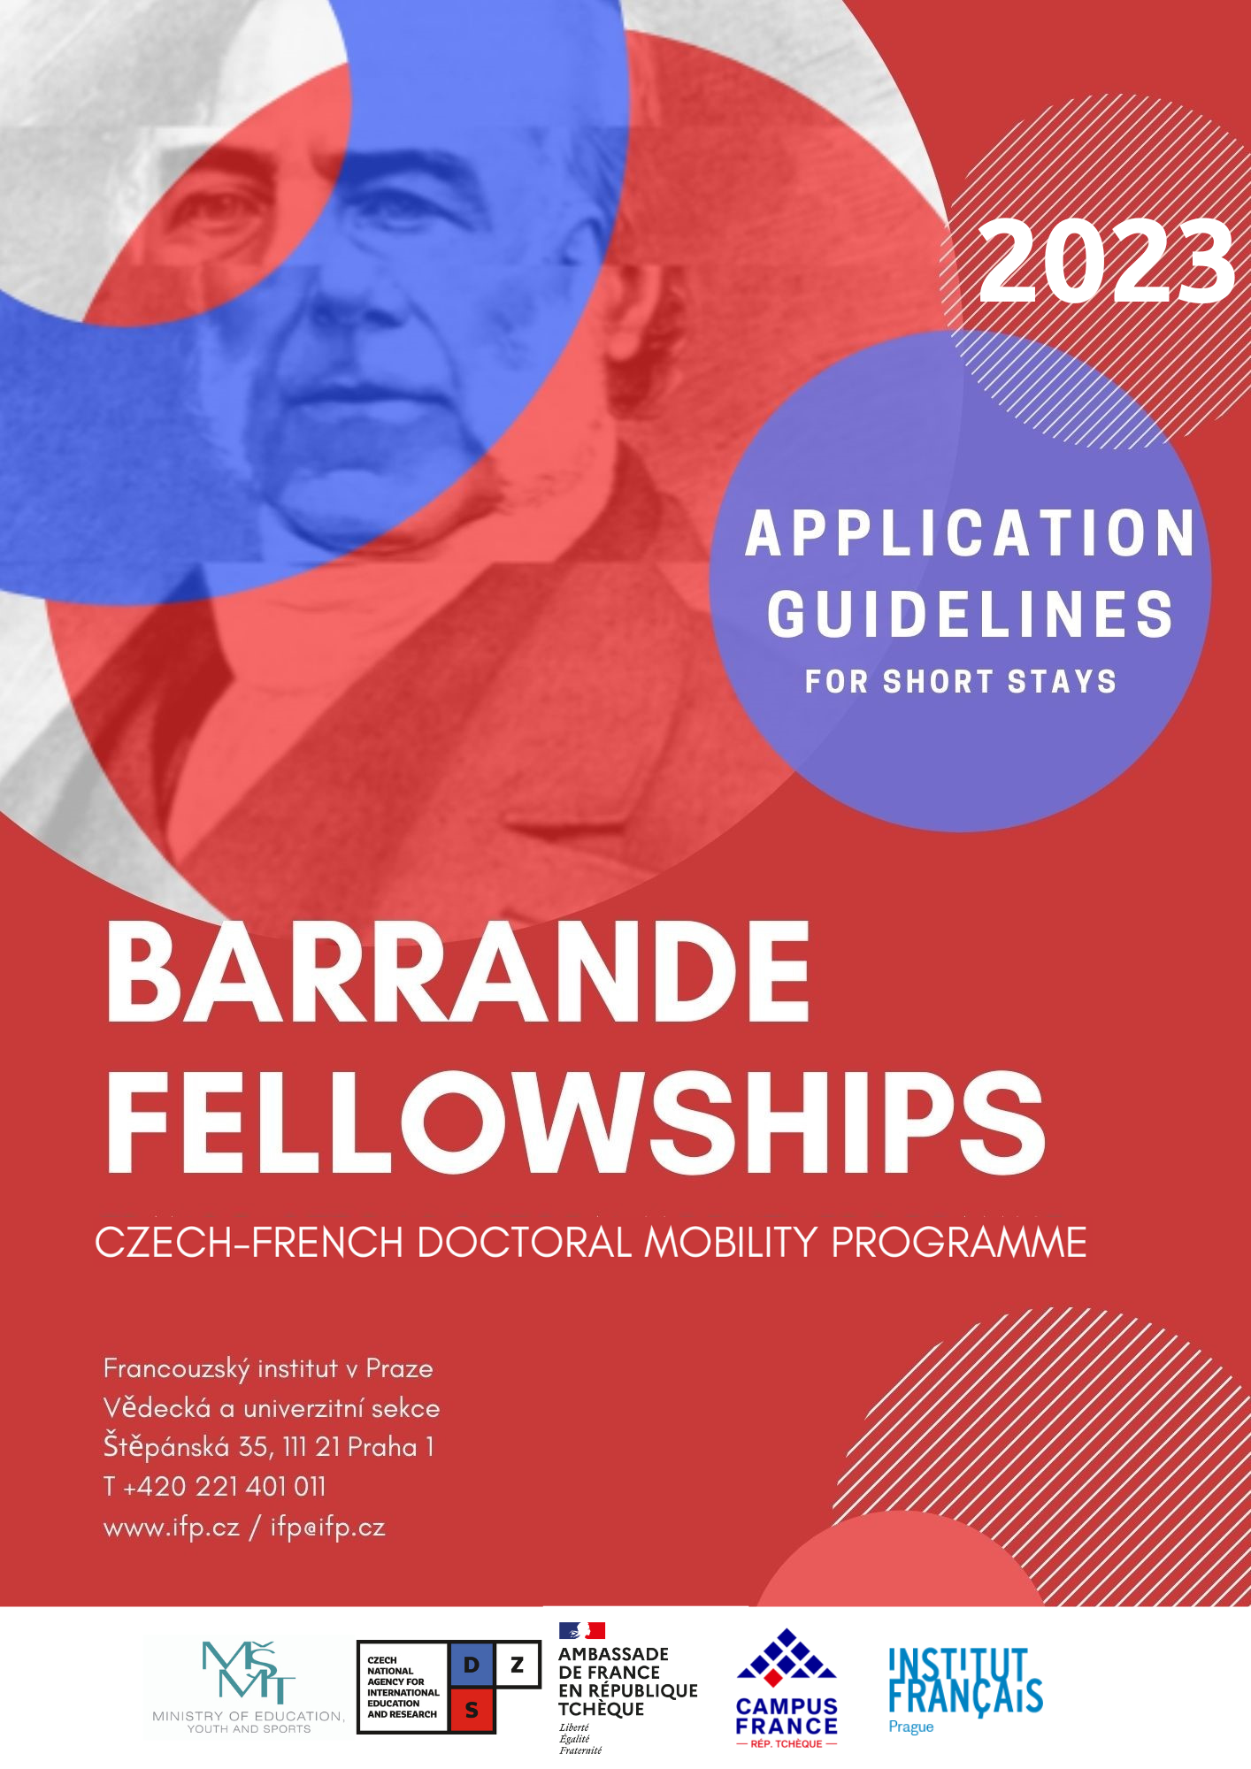
Programme objectives

The French Institute in Prague (IFP) and the Czech Ministry of Education, Youth and Sports (MEYS) coordinate the Barrande fellowship programme, the exchange mobility programme for Ph.D. students between the Czech Republic and France. The programme is designed to provide Ph.D. students in the Czech Republic with opportunities to study in France and Ph.D. students in France with opportunities to study in the Czech Republic. With all the scientific fields being represented, it enables Ph.D. students to acquire international expertise in humanities, life and natural sciences, exact sciences and engineering, economical and juridical sciences, medicine and others.
The aim of the programme is to enhance international education exchange while encouraging scientific cooperation between French and Czech research teams. Students from France and the Czech Republic are encouraged to extend their research abroad and learn new skills they will be able to develop further in their home countries. They are to become the spearheads of French-Czech bilateral relations. In pursuit of this aim, the programme funds “cotutelles” and short-term research stays.
While the call is open to all scientific fields, it particularly welcomes applications in the fields of environmental sciences, energy, mathematics and information technologies.

Eligibility

- Nationality
The programme is open to all Ph.D. students registered at a Czech higher education institution for studies in France (except for French citizens), and to all Ph.D. students registered at a French higher education institution for studies in the Czech Republic.

- Degree requirements
Students need to be enrolled in a doctoral study programme when beginning their research stay abroad.

- Faculty requirements
Research stays take place at a university, a research centre (public or private), or a university hospital.
- In the Czech Republic. Beneficiaries from French universities will receive the grant from the Czech public institution of higher education. Therefore, the applicant is obliged to contact his/her academic supervisor in the Czech Republic and gain acceptance. Together with him/her, the applicant will take steps towards the admission to his/her target faculty which will eventually make the payment of the grant. Here, you can find the public Higher Education Institutions/Research centres in the Czech Republic (MEYS, Study In) and the faculties in keeping with your research theme.
- In France. Applicants from Czech universities who need information on research opportunities in France will find it on the Campus France website (mapping of French research in all scientific fields and the list of French research labs). Beneficiaries are obliged to contact their target academic supervisor in France and gain acceptance.

- Language requirements
The programme is open to all English speakers on the condition that the French or Czech thesis supervisor from the foreign institution agrees with English as the language used during the stay.

Fellowship

The programme offers grants to Ph.D. students for a short-term research stay in France or in the Czech Republic. Length of a short stay is between 1 and 3 consecutive months.
The fellowship-holder receives a monthly stipend of about 1 500 EUR in France / 35 000 CZK in the Czech Republic.

Stays abroad should ideally start on October 1st, 2023.

Transport from France to the Czech Republic and from the Czech Republic to France is at the expense of the beneficiary.

Supervision

The applicant should contact the academic supervisor or the faculty/department he/she has chosen, introduce himself/herself, present his/her academic results, then outline the purpose of his/her stay and indicate the period of his/her planned stay. A mention about applying for the Barrande Fellowship should be made as well.
Applicants are advised to inquire first about the existing French-Czech relations at the applicant’s home university. If there are none in keeping with the applicant’s research theme, the applicant is encouraged to take his/her own initiative in this respect.

Application package

- Academic CV (2 pages max) in English
The contact details of the applicant must be specified (personal and professional e-mail address and phone numbers).
- Cover letter (2 pages max) in English
Explain the student’s motivation for applying for the fellowship, present his/her subject of research, explain his/her reasons for wishing to do research at the particular foreign institution.
- Description of the project (2 pages max, with references on the 3rd page) in English
Explain the research topic, specify the research objectives, methodology and expected research results. Develop a detailed study plan with a timeline. State the names and contact information of the Czech and French supervisors and include the expected dates of the stay abroad.
- Please note that the header must include the following information: Name/first name of the applicant - Subject of thesis - Name/first name of supervisors/addresses of universities.
- Signed recommendation letter from the supervisor at the home university with the letterhead of the institution
It should contain the supervisor’s agreement with the research project and with its being conducted under dual supervision. It should be written in English and contain the expected dates of the stay at the foreign institution. The letter should also highlight the student’s qualities, his/her research work and explain the benefit of the research stay abroad.
- You may use the template in Appendix 1.
- Signed recommendation letter from the supervisor at the foreign university with the letterhead of the institution
It should contain his/her agreement with the research project, willingness to welcome him/her at the foreign university and the commitment to conduct research under his/her supervision. It should be written in English and contain the expected dates of the stay at the foreign institution.
- You may use the template in Appendix 2.
Where necessary the supervisor may state that the student is invited to the foreign institution on the condition that he/she has graduated from the master’s study programme at the home university.
By signing the letter, the supervisor commits himself/herself to inform the faculty/higher education institution/research centres about the intention of the student to apply for the Barrande Fellowship and provide him/her with the contacts on the staff responsible for practical issues at the higher education institution/research centre after the applicant is selected.
- A transcript of the most recent academic achievements
Transcript of records or a copy of the Diploma Supplement issued by the university of previous degree program.

How to apply

- Submit the on-line registration form.
- Download and fill in the scholarship application form (see document in appendix 3).
- Prepare all the required documents (see above).
- Send the signed and completed application form along with all the required documents by e-mail to aia@dzs.cz. All the documents must be submitted by February 12th, 2023 at the very latest.

The materials should be submitted in a PDF version with respect to these rules:
Each file in the folder should be named using the following template: LAST NAME First name – Document title (Example: SMITH John – CV)
The application package should be in a compressed folder titled LAST NAME First name – Short-term stay – Category (Example: SMITH John – Short-term stay – LSM)
The folder name contains the initials of one of these 6 categories in keeping with the academic field of applicant’s research:
- Human Life Sciences and Health (LSH)
- Biology & Environment (B&E)
- Human & Social Sciences, Economics (SHSE)
- Chemistry (CH)
- Physics/Engineering (PE)
- Maths/IT/Systems Engineering (MITSE)

Selection procedure

- The Czech National Agency for International Education and Research (DZS) will check the eligibility of every applicant as well as the formal completeness of his/her application.

- Based on the quality of the written applications, auditions will be organized during March 2023.

The auditions will last 20 minutes which includes a 10-minute presentation by the applicant followed by a 10-minute discussion with the jury. Due to the epidemiological situation, the auditions will be taking place on-line, using the Zoom platform.
Applicants will be evaluated according to the criteria presented below, using a 10-point scale to assess their degree of fulfilment.
- Quality and soundness of the written application
- Quality and scientific relevance of the applicant’s research project
- Importance and relevance of the applicant’s research project for his/her professional development
- Value of academic support provided by the applicant’s thesis supervisor(s)
- Impact of the research stay abroad on a successful completion of the research project
- Professional competence of the applicant to successfully complete his/her research project
- Quality of the oral presentation
- Overall assessment of the application

Candidates whose research projects receive fewer than 70% of the maximum score will be eliminated from the competition. NB: Receiving a score higher than 70% does not automatically entitle the applicant to the fellowship.

Other important notes

Accommodation
- In France. Finding accommodation in France can prove difficult, especially in larger cities; it is, therefore, strongly advised that students start their inquiries early on and get in touch with their host university’s doctoral school to provide them with the necessary support. Depending on their status, students may also benefit from the Campus France support in their search for appropriate housing.
- In the Czech Republic. Inexpensive accommodation at student dormitories is offered as well as the possibility to have meals at student catering facilities. Beneficiary has to apply for accommodation at the receiving faculty well before his/her arrival. Students accommodated at university dormitories reimburse the related lodging expenses themselves. The applicants for research-stays in the Czech Republic should contact the hosting higher education institutions/ faculties regarding accommodation.

Calendar

Sunday, February 12th, 2023 | Application deadline
Mid-March 2023 | Auditions
End of April 2023 | Announcement of results

Contacts

Louis Augendre
louis.augendre@ifp.cz
Science programmes officer
Institut français de Prague
Štěpánská 35 - PO BOX 850 - 111 21 PRAGUE 1
Phone: (+420) 221 40 10 24
Fax: (+420) 221 40 10 54
Website: www.ifp.cz and cz.ambafrance.org

Appendix 1: Letter from the supervisor at the home university
[Insert letterhead of the institution]

At [place], on [date],

Object: Letter from the supervisor at the home university

To the Barrande Fellowship Committee,

Hereby, I, [First Name – Name –Position], in the role of the supervisor at [Institution’s name], gladly recommend [First Name – Name of the applicant], [Ph.D./future Ph.D. student] at [home institution’s name] for admission for a [short-term research stay] in the framework of the Barrande Fellowship Programme 2023.

[Presentation of the Applicant, his/her research work and academic achievement]

[Explanation of the interest for sending him to the foreign university in regards of his research and of the relations between the home and foreign institutions—the expertise of both laboratories/research centres should be demonstrated by references (publication, projects, etc.)]

In short, I strongly and without reservations recommend [First Name – Name of the applicant], as a candidate for the Barrande Fellowship Programme.

I fully agree with his proposed project and to conduct the supervision of his research jointly with [First Name – Name –Position of the supervisor at the foreign institution] at [Foreign institution’s name], and with the expected dates of stay:
[List of the expected dates of stay at the foreign institution]

Sincerely,

Signature

[First Name – Name
Position
Institution
E-mail
Telephone number]

Appendix 2: Letter from the supervisor at the foreign university
[Insert letterhead of the institution]

At [place], on [date],

Object: Letter from the supervisor at the foreign university

To the Barrande Fellowship Committee,

Hereby, I, [First Name – Name –Position] in the role of the supervisor at [Institution’s name], am pleased to invite [First Name – Name of the applicant], [Ph.D./future Ph.D. student] for a [short-term research stay] at [Institution’s name] in the framework of the Barrande Fellowship Programme 2023.

[Presentation of the Applicant and his/her research work]

[Explanation of the interest in receiving him/her in regards of his research and of the relations between the home and foreign institutions—the expertise of host laboratories/research centres should be demonstrated by references (publication, projects, etc.)]

In short, I strongly and without reservations recommend [First Name – Name of the applicant] as a candidate for the Barrande Fellowship Programme.

I fully agree with his/her proposed project and to conduct the supervision of his/her research jointly with [First Name – Name –Position of the supervisor at home institution] at [home institution’s name], and with the expected dates of the stay:
[List of the expected dates of the stay at the foreign institution]

Sincerely,
Signature

[First Name – Name
Position
Institution
E-mail
Telephone number]

Appendix 3: Scholarship Application Form

ID number* |  | Date of submission*
* Applicants leave these fields blank

Host country | ☐ Czech Republic  ☐ France |  | Academic year | 2023/2024
Type of mobility | ☐ cotutelle (double degree)  ☐ short stay |  | Length of study/research stay  (in months)
Host institution | ☐ university*
 | ☐ R&D center
* Please note that the specification of a university and faculty is necessary if applying for a cotutelle/short-term stay in the Czech Republic.

APPLICANT’S DATA
Family name |  | First name(s)
Date of birth (DD/MM/YYYY) |  | Academic degree
Gender | ☐ M  ☐ F | Citizenship
Mailing address
E-mail |  | Phone number

Home university |  | Faculty
Address of the home university
Year of study |  | Course of study | Ph.D.
Field of study
Title of the thesis subject
Language proficiency

PLEASE SELECT THE AREA THAT MATCHES YOUR THESIS SUBJECT:
☐ Human Life Sciences and Health
☐ Biology & Environment
☐ Human & Social Sciences, Economics
☐ Chemistry
☐ Physics/Engineering
☐ Maths/IT/Systems Engineering

I ATTACH THE FOLLOWING REQUIRED DOCUMENTS:
☐ Academic CV  ☐ Cover letter  ☐ Description of the research project  ☐ Transcript of records or a copy of the Diploma Supplement issued by the university of previous degree program | ☐ Letter from my original supervisor accepting a cotutelle or a short stay in the other country  ☐ Letter from the supervisor from the other country declaring willingness to supervise me for a cotutelle or invite me for a short stay
All the application documents must be in English.
1. In order to apply, please fill in the online REGISTRATION FORM.
2. Print this PDF application form, complete the appropriate sections, sign the form and send it along with the required documents by e-mail to aia@dzs.cz.

☐ I understand that this programme only provides support for mobility periods in the host country.
☐ I hereby acknowledge that my personal data provided in the application form and in the attachments and submitted for the purpose of selection proceedings as well as for the purpose of my possible later nomination will be processed by the Ministry of Education, Youth and Sports of the Czech Republic, by the Czech National Agency for International Education and by the French Ministry of Foreign Affairs represented by the French Embassy in the Czech Republic, in compliance with the Regulation (EU) 2016/679 of the European Parliament and of the Council of 27 April 2016 on the protection of natural persons with regard to the processing of personal data and on the free movement of such data, and repealing Directive 95/46/EC (General Data Protection Regulation). I also hereby acknowledge the fact that my aforementioned personal data will be forwarded to the appropriate host university in the Czech Republic and to Campus France, the French mobility agency for students, since this is necessary for the processing of my scholarship application. I also acknowledge that my personal data will be stored in analogue documents as well as the digital form by the Ministry of Education, Youth and Sports of the Czech Republic and by the Czech National Agency for International Education and that for a necessary period stipulated in their respective File Retention and File Destruction Rules.

Date
Handwritten signature

