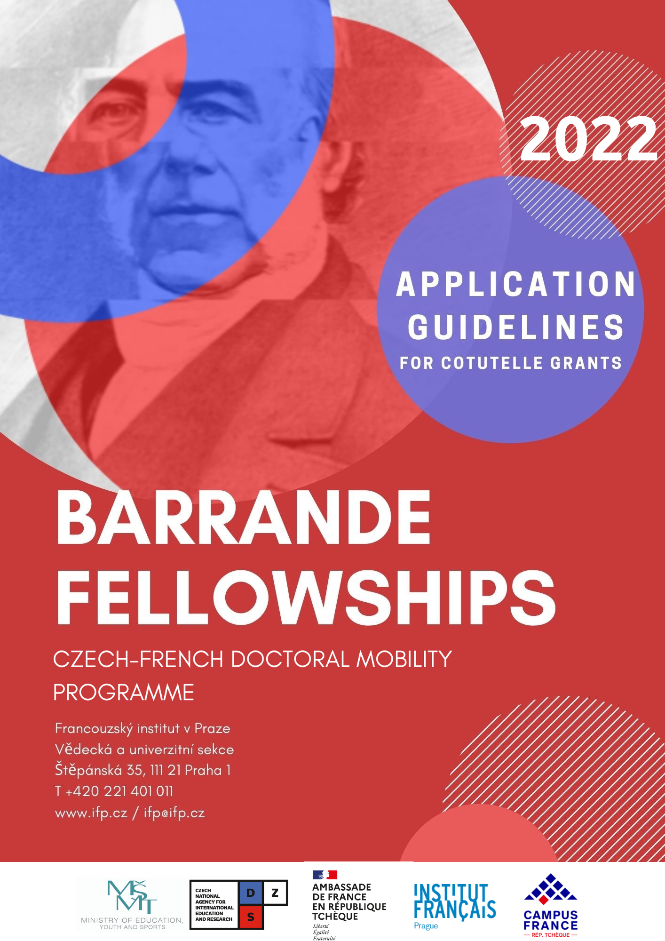
Programme objectives

The French Institute in Prague (IFP) and the Czech Ministry of Education, Youth and Sports (MYES) coordinate the Barrande fellowship programme, the exchange mobility programme for Ph.D. students between the Czech Republic and France. The programme is designed to provide Ph.D. students in the Czech Republic with opportunities to study in France and Ph.D. students in France with opportunities to study in the Czech Republic.
The aim of the programme is to enhance international education exchange while encouraging scientific cooperation between French and Czech research teams. Czech and French students are encouraged to extend their research abroad and learn new skills they will be able to develop further in their home countries. They are to become the spearheads of French-Czech bilateral relations. In pursuit of this aim, the programme supports “cotutelles” and short-term research stays.
While the call is open to all scientific fields, it particularly welcomes applications in the fields of environmental sciences, energy, and information technologies.

What is a “cotutelle”?

The scheme called “cotutelle” is a doctoral degree programme which is undertaken jointly at two partner higher education institutions, one in France and the other in the Czech Republic. Research is conducted under the joint supervision of the Czech and the French supervisors, both providing the full measure of supervision for the student. The student undergoes multiple stays abroad, under the terms of the agreement co-signed by the Czech and the French higher education institution, the “Convention de cotutelle”, for a maximum of three years. On its completion, the student is awarded two diplomas, one from each institution.
Applicants should launch the process of finalising the “cotutelle” agreement as soon as possible, since this is one of the prerequisites for receiving the scholarship.

Eligibility

- Nationality
The programme is open to all Ph.D. students registered at a Czech higher education institution for studies in France (except for French citizens) and to all Ph.D. students registered at a French higher education institution for studies in the Czech Republic.

- Degree requirements
Students need to hold a higher education diploma before their first stay abroad.
- In France, in order to register as a Ph.D. student, it is necessary to hold either a Master’s degree or to get an equivalence certificate for this diploma. Such equivalence is delivered by the French university. Applicants for the Barrande fellowship should ask their French supervisor about the procedure to receive this equivalence certificate.
- In the Czech Republic, access to a doctoral study programme is conditional on graduating from a master’s study programme. See the diagram of the education and degree system in the Czech Republic.
It is necessary to be enrolled in a doctoral study programme both at a Czech and a French university.

- Faculty requirements
- In the Czech Republic. Applicants from French universities are advised to thoroughly read Application Procedure and Admission Requirements for the academic year 2022/2023 published by their target faculty in the Czech Republic and check the deadline for the application submission. Thereafter, applicants need to apply for a full-time doctoral study programme through the faculty’s registration system. Please find official information on the website of the target public Higher Education Institution in the Czech Republic (MEYS, Study In).
- In France. Applicants from Czech universities will find general information on enrolment in a Ph.D. programme in France on the Campus France website. Registration procedures can be found on the website of the targeted doctoral school (list and website of all French doctoral schools).

- Language requirements
- The programme is open to all English speakers on the condition that the French or Czech thesis supervisor from the foreign institution agrees with English as the language used for the Ph.D.

Fellowship

The programme offers grants to Ph.D. students studying in the frame of a “cotutelle” between France and the Czech Republic. The fellowship is awarded for each research stay abroad. The fellowship-holder registered in a Czech or a French university undertakes a 5-month stay abroad every year for a maximum of 3 years and maximum of 15 months.

The fellowship-holder receives a monthly stipend in the amount of 1,000 EUR in France / 25,000 CZK in the Czech Republic.

Stays abroad should ideally start on October 1st or November 1st and therefore follow the scheme presented below:
Stay 1: October 1st, 2022 – February 28th, 2023
Stay 2: October 1st, 2023 – February 29th, 2024
Stay 3: October 1st, 2024 – February 28th, 2025

or

Stay 1: November 1st, 2022 – March 31st, 2023
Stay 2: November 1st, 2023 – March 31st, 2024
Stay 3: November 1st, 2024 – March 31st, 2025

Transport from France to the Czech Republic and from the Czech Republic to France is at the expense of the beneficiary.

NB: The programme supports the mobility of students to their host institution. It does not provide for a research contract for the full duration of a Ph.D.

Supervision

The applicant should contact the academic supervisor or the faculty/department he/she has chosen, introduce himself/herself, present his/her academic results, then specify the programme in which he/she wants to study and indicate the period of his/her planned stay. A mention about applying for the Barrande Fellowship should be made as well.

Applicants are advised to inquire first about the existing French-Czech relations at the applicant’s home university. If there are none in keeping with the applicant’s research theme, the applicant is encouraged to take his/her own initiative in this respect.
Application package

- Academic CV (2 pages max) in English
The contact details of the applicant must be specified (personal and professional e-mail address and phone numbers).
- Cover letter (2 pages max) in English
Explain the motivation for applying for the fellowship, present the subject of research, explain the reasons for wishing to do research at the particular foreign university.
- Description of the project (2 pages max, with references on the 3rd page) in English
Explain the research topic, specify the research objectives, methodology and expected research results. Develop a detailed study plan with a timeline. State the names and contact information of the Czech and French supervisors and include the expected dates of each stay abroad.
- Please note that the header must include the following information: Name/first name of the applicant - Subject of thesis - Name/first name of supervisors/addresses of universities.
- Signed recommendation letter from the supervisor at the home university with the letterhead of the institution
It should contain the supervisor’s agreement with the research project and with its being conducted under the joint supervision. It should be written in English and contain the expected dates of each stay at the foreign institution. The letter should also highlight the student’s qualities, his/her research work and explain the benefit of conducting the research project in the framework of the co-tutelle.
- Appendix 1 may be used as a template.
- Signed recommendation letter from the supervisor at the foreign university with the letterhead of the institution
It should contain his/her agreement with the student’s research project, willingness to welcome him/her at the foreign university and the commitment to conduct his/her research under the joint supervision. It should be written in English and contain the expected dates of each stay at the foreign institution. The letter should also explain the reasons for implementing the co-tutelle (i.e. complementarity of expertise) as well as potential success factors.
- Appendix 2 may be used as a template.
Where necessary, the supervisor may state that the student is invited to the foreign institution on the condition that he/she has graduated from the master’s study programme at his/her home university.
By signing the letter, the supervisor commits himself/herself to inform the faculty / doctoral school / higher education institution about the intention of the student to apply for the Barrande Fellowship and provide him/her with the contacts on the staff responsible for practical issues at the higher education institution after the applicant is selected.
- A transcript of the most recent academic achievements (transcript of records for the last two years of studies).

How to apply

- Submit the on-line registration form.
- Download and fill in the scholarship application form (see document in appendix 3)
- Prepare all the required documents (see above).
- Send the signed and completed application form along with all the required documents by e-mail to aia@dzs.cz. All the documents must be submitted by February 4, 2022 at the very latest.

The materials should be submitted in a PDF version with respect to these rules:
Each file in the folder should be named using the following template: LAST NAME First name – Document title (Example: SMITH John – CV)
The application package should be in a compressed folder titled LAST NAME First name – Cotutelle – Category (Example: SMITH John – Cotutelle – LSM)
The folder name contains the initials of one of these 3 categories in keeping with the academic field of your research:
- Human Life Sciences & Health (LSH)
- Biology & Environment (BE)
- Social & Human Sciences, Economics (SHSE)
- Chemistry/Physics/Engineering (CPE)
- Maths/IT/Systems Engineering (MITSE)

Selection procedure

- The Czech National Agency for International Education and Research (DZS) will check the eligibility of every applicant as well as the formal completeness of his/her application.

- Based on the quality of the written applications, auditions will be organized during the weeks of March 7th, 2022 to March 18th, 2022.

The auditions will last 20 minutes which includes a 10-minute presentation by the applicant followed by a 10-minute discussion with the jury.
Applicants will be evaluated according to the criteria presented below, using a 10-point scale to assess their degree of fulfilment.
- Quality and soundness of the written application
- Quality and scientific relevance of the applicant’s research project
- Organisation and added value of the co-tutelle project
- Importance and relevance of the applicant’s research project for his/her professional development
- Value of academic support provided by the applicant’s thesis supervisor(s)
- Professional competence of the applicant to successfully complete his/her research project
- Quality of the oral presentation
- Overall assessment of the application

Candidates whose research projects receive fewer than 56 points out of 80 will be eliminated from the competition. NB: Receiving a score higher than 56 points does not automatically entitle the applicant to the fellowship.

Other important notes

Accommodation
- In France. Finding accommodation in France can prove difficult, especially in larger cities; it is, therefore, strongly advised that students start their inquiries early on and get in touch with their host university’s doctoral school.
Depending on their status, students may benefit from the Campus France support in searching for appropriate housing in a university residence. In addition, students may ask for state housing benefit („Aide pour le logement – APL“) once they are in France. Applications are submitted to the Caisse d’Allocation Familiale – CAF, in their host city.
- In the Czech Republic. Inexpensive accommodation at student dormitories is offered as well as the possibility to have meals at student catering facilities. Beneficiary has to apply for accommodation at the receiving faculty well before his/her arrival. Students accommodated at university dormitories reimburse the related lodging expenses themselves. The applicants for research stays in the Czech Republic should contact the hosting higher education institutions/ faculties regarding accommodation.

Calendar

Friday, February 4th, 2022 | Application deadline
From Monday, March 7th, 2022 to Friday, March 18th, 2022 | Evaluation Committees (oral presentations)
April 15th, 2022 | Announcement of results

Contacts

Agathe Medjani-Daudé
agathe.medjani-daude@ifp.cz
Scientific programmes officer
Institut Français de Prague
Štěpánská 35 - PO BOX 850 - 111 21 PRAGUE 1
Phone: (+420) 221 40 10 24
Fax: (+420) 221 40 10 54
Website: www.ifp.cz and cz.ambafrance.org

Appendix 1: Letter from the supervisor at the home university

[Insert letterhead of the institution]

At [place], on [date],

Object: Letter from the supervisor at the home university

To the Barrande Fellowship Committee,

I, [First Name – Name – Position] in the role of the supervisor at [Institution’s name], gladly recommend [First Name – Name of the applicant], [Ph.D./future Ph.D. student] at [home institution’s name] to be awarded a Barrande Fellowship for a [cotutelle].

[Presentation of the Applicant, his/her research work and academic achievements]

[Explanation of the interest in sending him/her to the foreign university in regard to his/her research and to the relations between the home and foreign institutions—the expertise of both laboratories/research centers should be demonstrated by references (publications, projects, etc.)]

In short, I strongly and without reservations recommend [First Name – Name of the applicant], as a candidate for the Barrande Fellowship Programme.

I fully agree with his/her proposed project and to conduct the supervision of his/her research jointly with [First Name – Name –Position of the supervisor at the foreign institution] at [Foreign institution’s name], and with the expected dates of the stays:
[List of the expected dates of thestays at the foreign institution]

Sincerely,

Signature

[First Name – Name
Position
Institution
E-mail
Telephone number]

Appendix 2: Letter from the supervisor at the foreign university

[Insert letterhead of the institution]

At [place], on [date],

Object: Letter from the supervisor at the foreign university

To the Barrande Fellowship Committee,

I, [First Name – Name –Position] in the role of the supervisor at [Institution’s name], am pleased to invite [First Name – Name of the applicant], [PhD/future PhD student] for a [cotutelle] at [Institution’s name].

[Presentation of the Applicant and his/her research work]

[Explanation of the interest in receiving him/her in regards of his/her research and of the relations between the home and foreign institutions—the expertise of host laboratories/research centres should be demonstrated by references (publication, projects, etc.)]

In short, I strongly and without reservations recommend [First Name – Name of the applicant] as a candidate for the Barrande Fellowship Programme.

I fully agree with his/her proposed project and to conduct the supervision of his/her research jointly with [First Name – Name –Position of the supervisor at home institution] at [home institution’s name], and with the expected dates of the stays:
[List of the expected dates of the stays at the foreign institution]

Sincerely,

Signature

[First Name – Name
Position
Institution
E-mail
Telephone number]

Appendix 3 – Barrande Fellowship application form

ID number* |  | Date of submission*
* Applicants leave these fields blank

Host country | ☐ Czech Republic  ☐ France |  | Academic year | 2022/2023
Type of mobility | ☐ cotutelle (double degree)  ☐ short stay |  | Length of study/research stay  (in months)
Host institution | ☐ university*
 | ☐ R&D center
* Please note that specification of a university and faculty is necessary if applying for a cotutelle/short-term stay in the Czech Republic.

APPLICANT’S DATA
Family name |  | First name(s)
Date of birth (DD/MM/YYYY) |  | Academic degree
Gender | ☐ M  ☐ F | Citizenship
Mailing address
E-mail |  | Phone number

Home university |  | Faculty
Address of the home university
Year of study |  | Course of study | Ph.D.
Field of study
Title of the thesis subject
Language proficiency

PLEASE SELECT THE AREA THAT MATCHES YOUR THESIS SUBJECT:
☐ Human Life Sciences & Health
☐ Biology & Environment
☐ Human & Social Sciences, Economics
☐ Chemistry/Physics/Engineering
☐ Maths/IT/Systems Engineering

I ATTACH THE FOLLOWING REQUIRED DOCUMENTS:
☐ Academic CV  ☐ Cover letter  ☐ Description of the research project  ☐ Academic results obtained within last two years of studies | ☐ Letter from my original supervisor accepting a cotutelle or a short stay in the other country  ☐ Letter from the supervisor from the other country declaring willingness to supervise me for a cotutelle or invite me for a short stay
All the application documents must be in English.
1. In order to apply, please fill in the online REGISTRATION FORM.
2. Print this PDF application form, complete the appropriate sections, sign the form and send it along with the required documents by e-mail to aia@dzs.cz.

☐ I understand that this programme only provides support for mobility periods in the host country.
☐ I hereby acknowledge that my personal data provided in the application form and in the attachments and submitted for the purpose of selection proceedings as well as for the purpose of my possible later nomination will be processed by the Ministry of Education, Youth and Sports of the Czech Republic, by the Czech National Agency for International Education and by the French Ministry of Foreign Affairs represented by the French Embassy in the Czech Republic, in compliance with the Regulation (EU) 2016/679 of the European Parliament and of the Council of 27 April 2016 on the protection of natural persons with regard to the processing of personal data and on the free movement of such data, and repealing Directive 95/46/EC (General Data Protection Regulation). I also hereby acknowledge the fact that my aforementioned personal data will be forwarded to the appropriate host university in the Czech Republic and to Campus France, the French mobility agency for students, since this is necessary for the processing of my scholarship application. I also acknowledge that my personal data will be stored in analogue documents as well as the digital form by the Ministry of Education, Youth and Sports of the Czech Republic and by the Czech National Agency for International Education and that for a necessary period stipulated in their respective File Retention and File Destruction Rules.

Date
Handwritten signature

